Below you will find an example of how the lab reports should be completed and turned in. This is a lab report that I completed for my Soil Chemistry course. As required for lab there is a:

Title Page

Introduction

Results/Questions

Conclusion

<http://darkhorseanalytics.com/blog/clear-off-the-table/>

This is a link on how to make a table, chart, or any graphic publication ready.

The only addition they are missing is a Figure Label and a TITLE which can stand alone as the description of the following data.

If there are any other questions or formatting or the reports in general please stop by the office and discuss with your TA.

Patrick Watkins

ENST 421

3/2/11

**Laboratory #2:**

**Cation Exchange Capacity**

**Of a Watchung AP soil**

**(fine, smectitic, mesic Typic Albaqualfs**)

**Introduction:**

Cation exchange is an important property of soils. Soils carry an inherent charge with them which allows them to bind and immobilize ions. This bonding and immobilization plays a major role in determining whether ions are available for plant uptake, ground water leaching, or buildup of ions to toxic levels. Since all ions are different it is possible to determine which ions are more readily hydrated and replaced in the soil by other ions. Another important factor is an ions reluctance to hydrate and remain bound to the soil.

There are three factors which play a major role in determining which and where ions will be in the soil profile and their ability to either replace or resist replacement by other ions. The first factor is the hydration of Ions in Aqueous Solutions. Second, is the charge of the ion, and third the ion activity coefficient. If all three of these factors are considered it is possible to determine theoretically which ions will be present. This concept is called cation exchange and can be examined in the laboratory.

For the purpose of this lab we investigated the cation exchange capacity of a Watchung AP soil from Maryland. We will be looking at the relative replacing power of four different ions for exchangeable calcium. The process we went about to accomplish this is as follows. First, we weighed out a predetermined soil amount and saturated it with calcium using a 0.1 M CaCl2. Next we rinsed the sample twice with DDI water to make sure all free calcium was removed. In duplicates four ions of interest, Li+, K+, Mg2+, and Al3+ were added. Samples were shaken for one minute, allowed to stand for 15, and then centrifuged. Then supernatant was pipetted into test tubes, mixed with La solution, and diluted down with DDi water to make a 1:10 dilution. Samples were then vortexed to ensure homogeneity of the solution for the Atomic Absorption Spectrophotometer.

Before running our samples Lab standards were analyzed to create our standard curve. After the standards were processed the solutions were analyzed until a plateau was reached and steady readings occurred.

**Results:**

**Figure 1: Ca Standard Curve Calibrations utilizing an AA.**



**Figure 2: Relative Ca replacement for each extracting compound used.**



**Figure 3: Charge equivalents of Ca measured and the exchange percentage for each extracting compound used.**



**Figure 4: Standard Curve for Ca2+ Concentration utilizing an AA.**

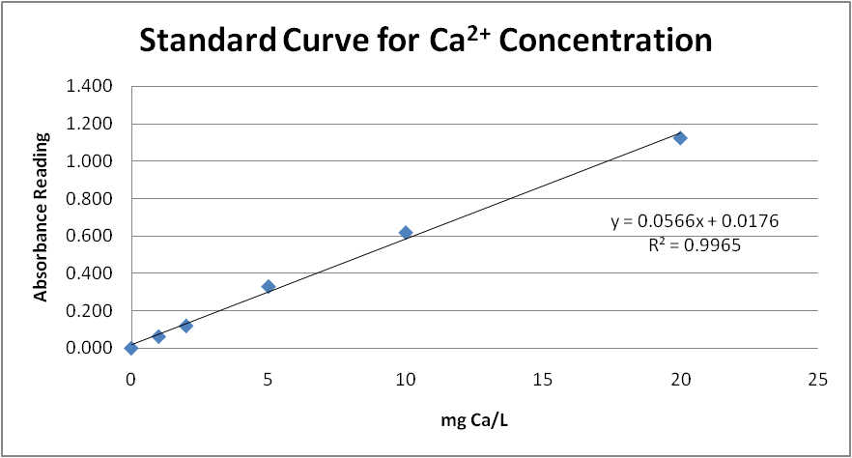

**QUESTIONS**

1. By putting the soil into solution with 0.1M CaCl2 we completely saturated all of the cation exchange sites of the soil.
2. By washing the soil solution with H2O any free unbound calcium was removed. If we had not washed the soil there is a chance that the amount of free calcium for exchange would not be related to the cation exchange capacity of that soil. Also, if washing had not occurred the amount of free calcium would be spiked and would have required standards that were much higher in concentration so that our measure absorbance would not exceed our standard absorbance which in turn would give us false readings of the CEC. Extreme high amounts fo calcium may also impede in the exchange for other cations.
3. The different molarities of the four extracting salts were due to the charge on each ion of the salts. By differing the molarity we are able to look at the ability of the ions to replace calcium.
4. I expected the cations to be as follows. Al, Mg, K, Li with Al having the highest replacement. My results somewhat matched my expectations. Our results showed that K replaced more calcium then Mg however we did note a possible error during dilution which explains the reason for the anomaly. Smectite clays are a 2:1 clay particles which will readily bond to the 3+ charge of aluminum. The charge on each replacing ion indicates the number of Ca ions it may replace. However in the case of K and Li it comes down to size comes into play. K and Ca are roughly the same size and therefore K has a greater replacing power than the smaller Li ion. Also, Li forms isomorphic bonds so it comes and goes and thus reducing its replacing power.
5. I would expect greater amounts of K to be leached from the soil amended with Al2(SO4) due to the 3+ charge on the Aluminum Ion. When aluminum bonds to a clay surface it attaches to 3 oxygen molecules. This tighter bond eliminates the possibility of K to take its place where as the Mg carries a 2+ charge and therefore may, in some cases, be replace by K when it is overwhelmed.
6. As the soil becomes saturated with K there is a possibility that K will then replace the Mg. When it is replaced the Mg may either leach or precipitate out of the soil in either case it is no longer available for plant use. This is more of an issue of ion concentration then CEC.
7. The maximum percentage of replacement was 68.26% and was achieved by the AlCL3. The procedure can be change by increasing the molarities of the extraction solutions to satisfy all of the + charge of the soil. The other option is to increase the volume of extraction solution so that the extractant overwhelms the Ca2+ ensuring that all Ca2+ is removed.

**Conclusion:**

This lab has demonstrated many different aspects. To begin with we re-familiarized ourselves with many different lab procedures. Ultimately though, this lab focused on the concept of cation exchange capacity of soils. In the lab we used a smectitic clay soil with a CEC of 150mmol(+)/kg soil. We then proceeded to saturate the soil with calcium. Once achieved, we extracted the calcium using four different extracting salts. We then proceeded to measure the extracted Ca thus indicating the replacing power of the four salts. In our lab we found Al to displace the most calcium out of the four salts. According to logic the next most powerful should have been the Mg. However, due to human error noted during the procedures we found K to be the next most powerful followed by Mg and then Li. The concept of CEC and ion displacement in soil types plays a major role in the agricultural community. Nutrients that are usually added to the soil for crop production come in many forms. With this in mind it is important for farmers to understand CEC and know their soil types to eliminate the possibility of creating nutrient deficiencies or toxicity issues. Also, the concept of CEC and ion displacement plays a major role in remediating and or retention of soil pollution. In understanding CEC and different clay structures scientists may better engineer and understand ion movement through soil solutions thus allowing them to both capture and retain or to wash and remediate the soil of pollution.