SOIL 4234 Laboratory #11
Soil Test for Potassium, Sulfur, and Tour of SWFAL (10 points)
Due Wednesday, October 31st

Student
Lab
TA

Objectives

1. Understand the process to determine and interpret a soil test K index.
2. Understand the process to determine and interpret a soil test S values.
3. To be familiarized with the services and laboratory procedures of the Soil, Water, and
Forage Analytical Laboratory at Oklahoma State University.

Fill in Blanks on Slides (5.5 points)
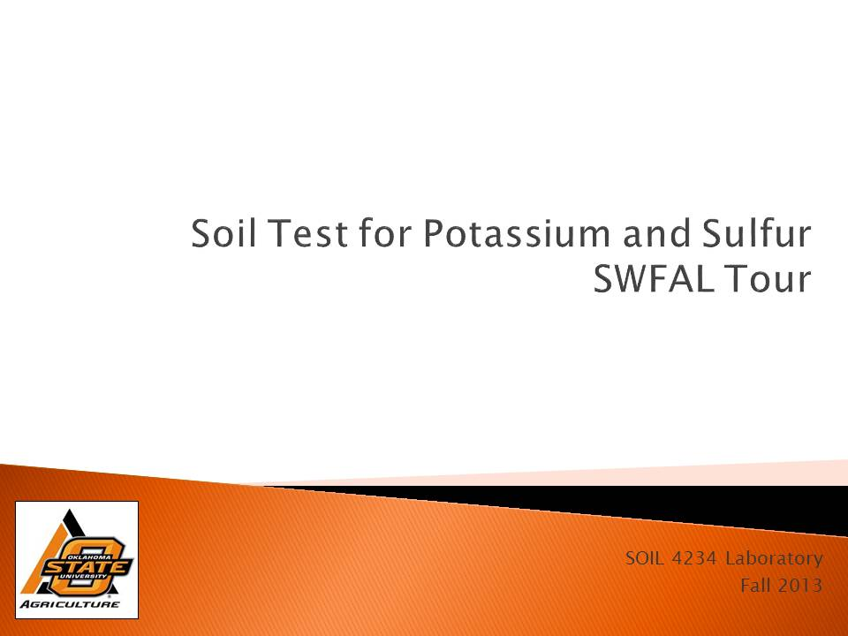

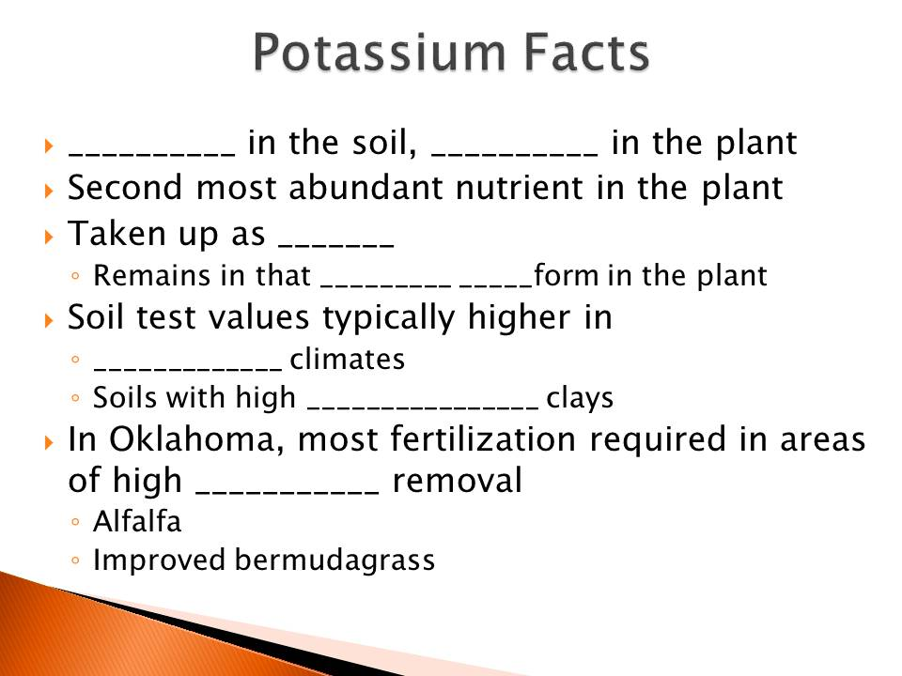

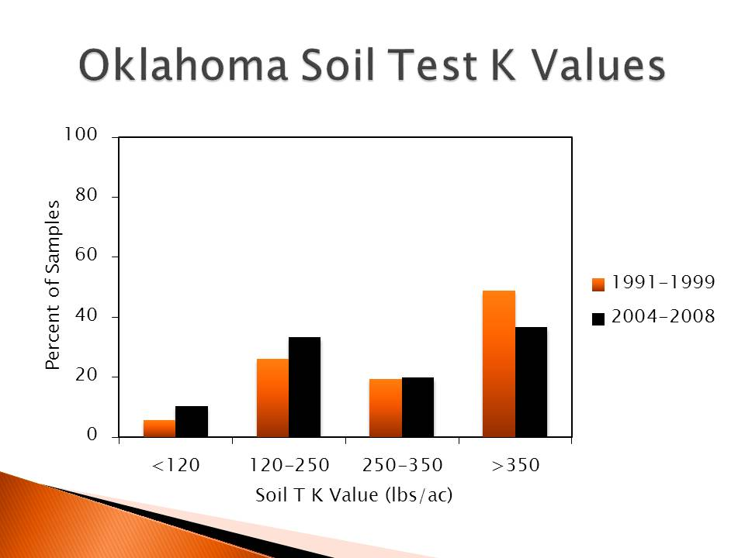

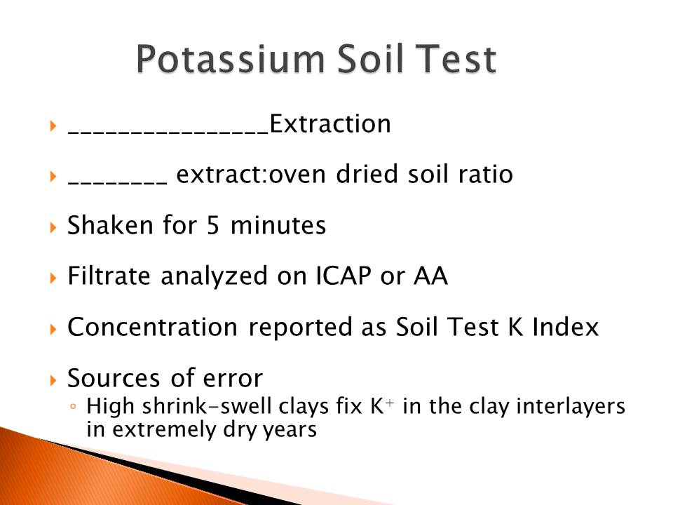

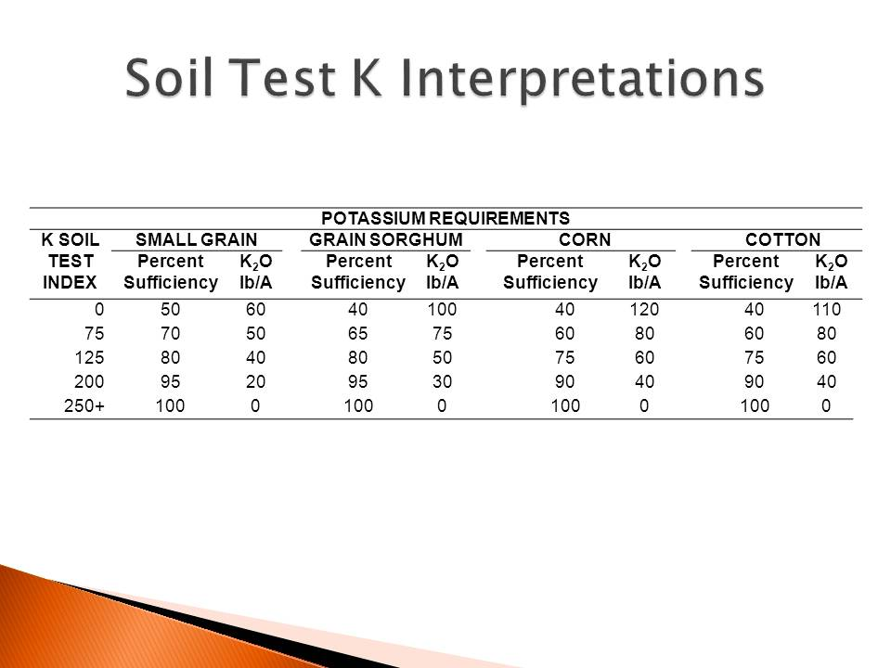

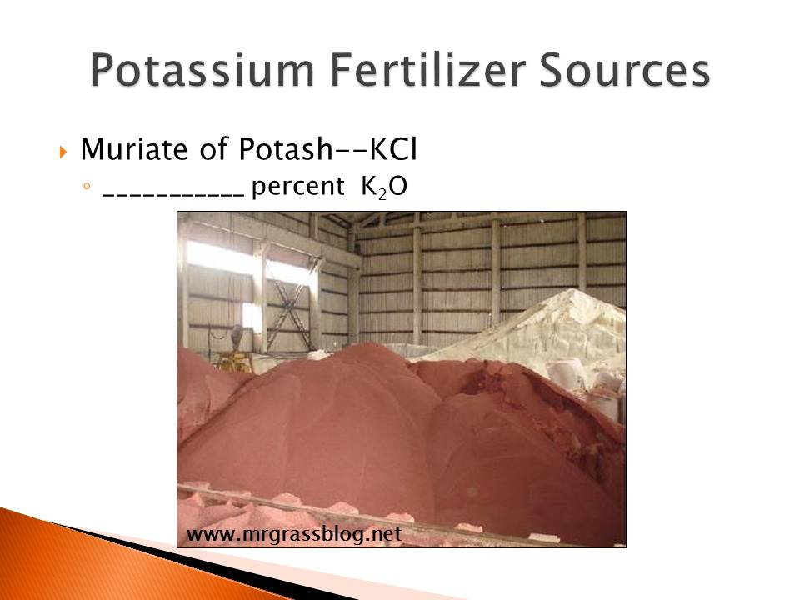

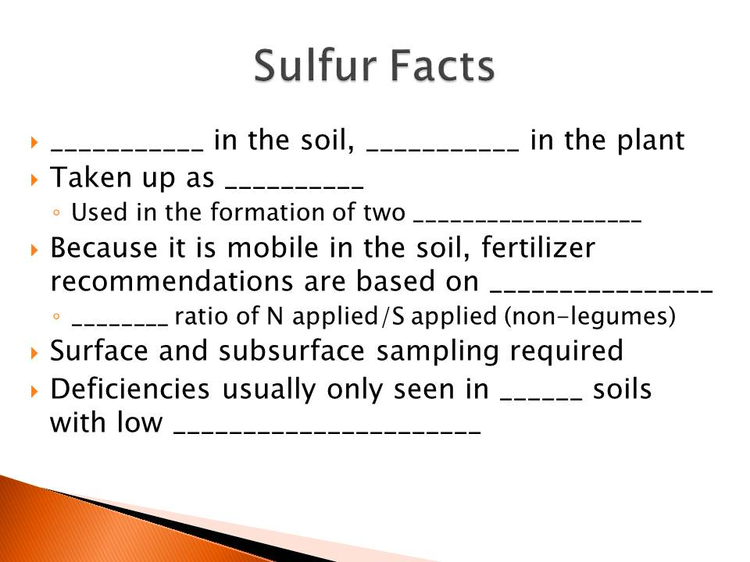

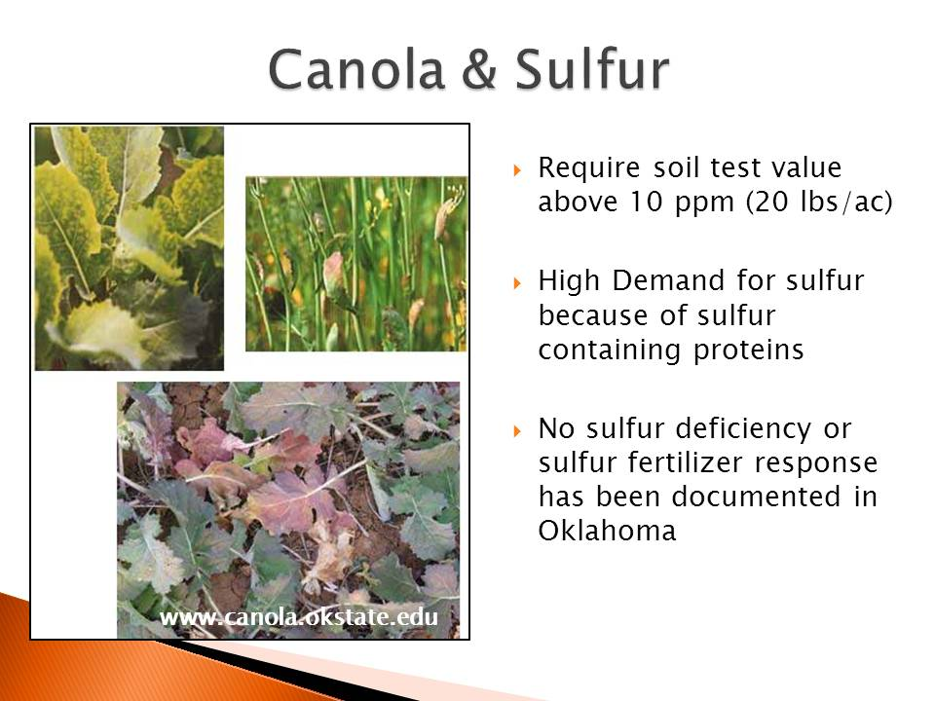

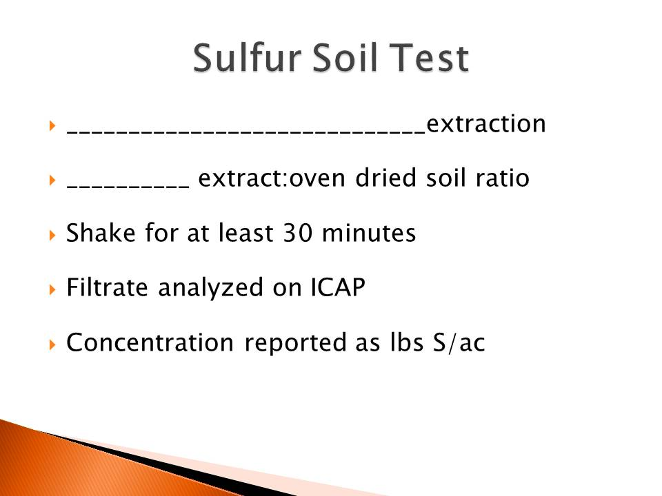

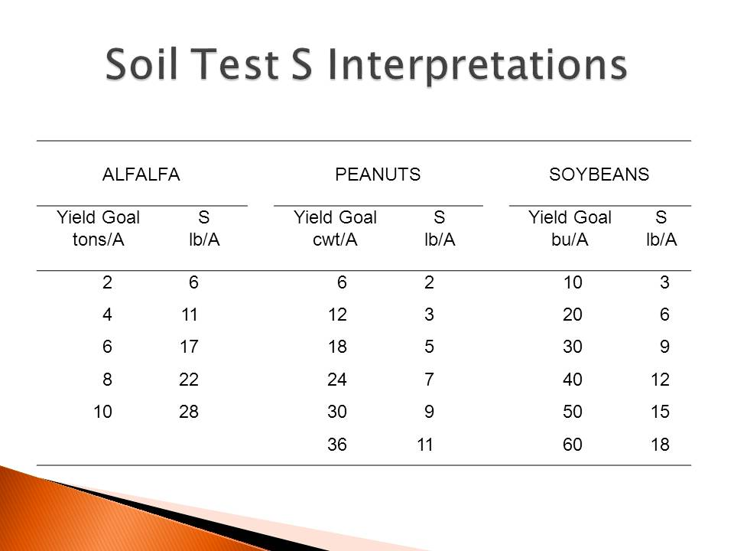

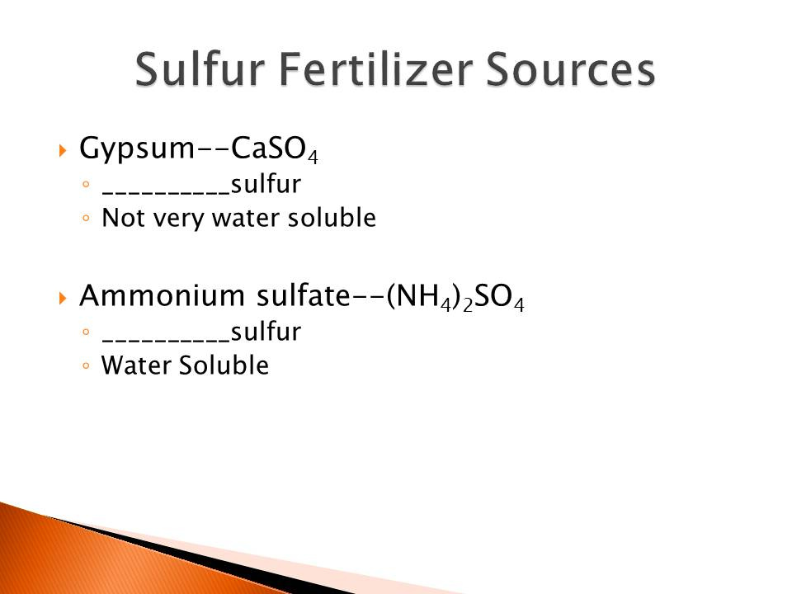
TURN IN THIS LAB!!!
NO LAB REPORT REQUIRED!!!

Questions

- (2.5 points) You are planning to plant cotton for the upcoming year. You have a yield goal of 2 bales/acre. Your K soil test index was 125. What would be the K fertilizer recommendation in lbs K₂O/acre?

- (2.5 points) You have a nitrogen fertilizer requirement of 200 lbs N/acre for your upcoming corn crop. Your surface sulfur soil test is 2 lbs S/acre and your subsurface sulfur soil test is 3 lbs S/acre. Based on the soil test results and the N fertilizer requirement, how many lbs of S/acre should you add?

- (1.5 point)What tests are preformed for a routine soil analysis?

- (1.0 point)What solution does SWFAL use to determine pH buffering capacity?

- (1.0 point) What nutrient(s) are measured on the ICAP?

6. (1.0 point)What nutrient(s) are measured with Mehlich 3 extractant?

