**SOIL 4234 Laboratory #5**

**Soil Test for Nitrogen (20 points)**

Student

Lab

TA

**Objectives**

1. Gain a basic understanding of the nitrogen cycle.
2. Identify soil analysis techniques for determining total soil nitrogen and inorganic soil nitrogen.
3. Recognize how soil testing for nitrogen effects winter wheat nitrogen fertilizer recommendations.

Whenever nitrate and/or ammonium nitrogen are measured in the soil, these measurements provide a view of two components of the N cycle at a single point in time. If the measurement is made when the system is likely to be in balance, or equilibrium, such as when wheatland soils are tested for nitrate in July or August, then the value can be a useful guide for determining N fertilizer needs. Figure 1 illustrates the changes that took place for ammonium and nitrate nitrogen in soil during wheat production under different rates of fertilizer use. Because ammonium and nitrate nitrogen are the two forms of nitrogen that higher plants utilize, these two forms have received the greatest attention.

OSU soil fertility research has documented the change of ammonium and nitrate nitrogen following fertilization (Fig. 1). Only about 60% of the fertilizer N could be accounted for at the first sampling after fertilization. This was mostly present as nitrate although the fertilizer (ammonium nitrate) was an equal mixture of the two nitrogen forms measured. Apparently in the short period after application, some transformations had taken place. These continued, resulting in a gradual increase in ammonium nitrogen (probably from some mineralization) and a rapid decline in nitrate, likely from immobilization caused by microbial activity and uptake by the wheat crop.

Harvesting removes significant amounts of nitrogen each year and eventually the system becomes depleted in organic matter and available N to support normal crop yields. A common response to this result is to begin adding nitrogen back by using legumes and commercial fertilizers. When additions are balanced with removals, soil organic matter and productivity can potentially be sustained. However, excessive tillage, residue removal (straw and chaff in wheat production) and residue burning often result in continued soil organic matter decline. This loss in soil organic matter also contributes to "hard" ground and soil that easily crusts after drying.



Figure 1. Surface soil (0-6”) ammonium and nitrate nitrogen following fertilization at different rates from OSU Soil Fertility Research.

Nitrogen (N) is a plant nutrient present in the highest concentration in plants and can often limit plant growth and yield. Nitrogen mostly exists in soil as part of soil organic matter. The N in soil organic matter is not available to plants until it is mineralized and released as ammonium (NH4+) which can further be transformed to nitrate (NO3-) with nitrification. The NO3-is readily leached from soils in climates with abundant rainfall. There is not a quick and efficient soil test that can reliably predict the amount of N in soil organic matter that would be mineralized and made available to plants. Nitrate will remain in soil with climates of limited precipitation since there is limited loss due to leaching and denitrification. The NO3-can be readily extracted from soil and analyzed. Soil sampling and analysis of NO3-can occur any time of year. For climates having significant rainfall, sampling soil for NO3-any part of the year does not provide useful information because of the high probability for NO3-loss. There is a soil test for corn where NO3-is determined in soil at the time when the crop is 8 to 12 inches tall and can be sidedressed with N fertilizer. This is close to the time when the crop will have maximum uptake of nutrients and soil NO3-concentrationat this time is a good indicator of NO3-availability to the crop. Two methods are described here for determining plant-available NO3-in soil. The first is a method primarily used in climates with limited rainfall where NO3-is not readily leached and remains in the soil. This method involves extraction of nitrate-nitrogen (NO3-N) from soils using 2M KCl. Nitrate is determined by reduction to nitrite (NO2-N) via acadmium reactor, diazotized with sulfanilamide and coupled to N-(1-Napthyl)-ethylenediamine dihydrochloride to form an azochromophore (red-purple in color) which is measured spectrophotometrically at 520 nm. The method is readily adapted to manual or automated techniques. The procedure follows the method outlined by Mulvaney (1996) for determining NO3-N with a modification that25 mL of 2 MKCl and 5 g of soil are used instead of 100 mL and 10 g soil, respectively. Since the measured NO3-N is available for plant uptake in climates with low annual precipitation, the test result can be credited toward crop nitrogen needs.

In our lab, we use a Hach product, called LACHAT Quikchem 8500. A flow injection analysis unit carries a sample with a carrier that mixes with reagents before reaching a detector. Generally automated, this is a very cheap analysis for nutrients. Depending on the nutrient that is being analysed for, reagents are interchangeable in the system. Figure 1 depicts the basics of flow injection analysis.

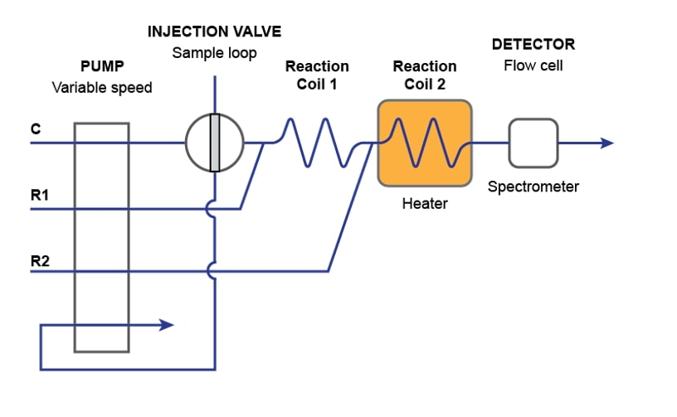

# Nitrogen Losses

# The major nitrogen loss from soils is the removal of nitrogen by harvest of non-legume crops. Other significant nitrogen losses include:

1. Volatilization of ammonia.
2. Volatilization of nitrous oxide (N2O) and nitric oxide (NO) from nitrate in poorly aerated soils (denitrification).
3. Leaching of nitrate out of the root zone in permeable soils receiving heavy rainfall or irrigation.
4. Volatilization of nitrogen (presumably as ammonia) from plants containing nitrogen in excess of what the plant can use in seed production, just after flowering.Figure 2. Addition of nitrogen to the nitrogen cycle from fixation of atmospheric nitrogen by: (9) lightning; (10) symbiosis with legumes; (11) industrial fertilizer plants.



Figure 3. Losses of nitrogen from the nitrogen cycle as a result of: (12) ammonia volatilization; (13) transformation of nitrate to gaseous oxides (denitrification); (14) leaching below the root zone; (15) volatilization from crops; and (16) harvest removal.

Each of these processes is only responsible for very small amounts of nitrogen loss over the course of a crop growing season. However, when considered over a generation of farming, or even just a few years, the amount of nitrogen lost can be significant. Nitrogen losses by these processes are at least partially responsible for the fact that only 50 to 70% of the fertilizer nitrogen applied is actually found in the crop. Research at OSU and other institutions continues to examine practices that will improve fertilizer nitrogen use efficiency. Figure 3 illustrates the interaction of these nitrogen losses with other forms of nitrogen and their transformations.

**Ammonia Volatilization from Urea Application Demonstration**

In Oklahoma, and much of the Central Great Plains in the US, the second most popular N-fertilizer sold is urea.  Much of the urea is applied as solid urea in a prill or pellet form; however, increasing amounts are being used as a solution of urea ammonium nitrate. When urea is applied to soil or plant surfaces it is possible for some of the N to be lost as ammonia gas into the atmosphere, referred to as ammonia volatilization in the nitrogen cycle.  This occurs as a result of urea conversion by the urease enzyme to ammonium bicarbonate.  When the surface dries the ammonium may be converted to ammonia and lost as a gaseous product.  The degree to which this happens depends on environmental conditions, especially temperature, soil pH, wetting and drying, soil texture, and wind.  This exercise examines some of these influencing factors, how much N may be lost, and how fertilizers may be managed to minimize loss.

Urea reacts with water in a humid environment to produce urea in solution.  When there is sufficient water the urea solution infiltrates and moves downward in the soil just as water alone because the dissolved urea is not and ion (it is uncharged).  Urea reacts with water (is hydrolyzed) by the enzyme urease, present in all soils and plant material (dead or alive) according to the following reaction:  
               NH2-CO-NH2 + 3 H2O + urease → 2 NH4+ + OH- + HCO3-                  (1)

The ammonium ions (2 NH4+) react with hydroxide (OH-) to form water and ammonia gas according to the reaction:   
              NH4+ + OH- ↔ H2O + NH3 (gas)                                              (2)

Loss of NH3 occurs (reaction goes to the right) when the environment dries (water is removed from the equation) and/or there is a continual supply or increase of hydroxide (basic solution is maintained).

In today’s lab, we will use the Lachat to analyze for NO3-N and NH4-N. Nitrate is determined by reduction to nitrite via a copperized cadmium column. The nitrite is then determined by diazotizing with sulfanilamide followed by coupling with N-(1-naphthyl)ethlyenediaminie dihydrochloride. The absorbance of the product is measured at 520 nm.

Ammonia determined by heating with salicylate and hypochlorite in an alkaline phosphate buffer. The presence of EDTA prevents precipitation of calcium and magnesium. Sodium nitroprusside is added to enhance sensitivity. The absorbance of the reaction product is measured at 660 nm and is directly proportional to the original ammonia concentration.

In order to put a sample though the flow injection analysis, an extraction of the nutrients must be done.

**Materials and Methods**

Extraction:

Weight out a sample of 5±0.1 grams of oven dried grinded sample into cup.

Add 25 mL of KCl extractant. Gives a 1:5 ratio of soil:extractant solution

Shake 30 minutes.

Filter out solution, disposing of any soil in trash, and put sample into LACHAT.

DATA:

Table

|  |  |  |
| --- | --- | --- |
| Nitrogen Analysis | | |
| Sample #:___1____ | | |
|  | NO3-N | NH4-N |
| Absorbance* | 8.62 | 12.9 |
| Ppm§ |  |  |
| Lbs/ac |  |  |
| Total N (lbs/ac): |  | |

* Value given from LACHAT

§ Value found by multiplying Absorbance by ratio of soil to extractant

For the second part of this lab, we will apply urea at 200 lbs N/acre to soil columns.  Conditions of the application will include soil texture, surface applied or incorporated, urease inhibitor (Agrotain), and high pH.  After treatments have been completed a cap will be placed over the end of the tubes to contain any NH3 that may be produced.  After a day of reaction time the cap will be replaced by a small coffee maker filter which will be secured over the end of the each tube with a rubber band.  Immediately following, universal indicator will be added to each coffee maker filter paper.

Complete the following table for relative NH3 loss due to volatilization based on color of the indicator-paper (dark blue = 10, green = 7, orange = 4, pink = 1).

Table

|  |  |  |
| --- | --- | --- |
| Trt # | Treatment | Relative N Loss |
| 1 | Sand Soil + Urea, surface applied. |  |
| 2 | Loam Soil + Urea, surface applied. |  |
| 3 | Sand Soil + Urea + Agrotain, surface applied. |  |
| 4 | Loam Soil + Urea + Agrotain, surface applied. |  |
| 5 | Sand Soil + Urea, incorporated. |  |
| 6 | Loam Soil + Urea, incorporated. |  |
| 7 | Sand Soil + Urea + Agrotain, incorporated. |  |
| 8 | Loam Soil + Urea + Agrotain, incorporated. |  |
| 9 | Sand Soil + Urea + Lime, surface applied. |  |
| 10 | Sand Soil + Urea + Lime, incorporated. |  |
| Urea is applied at 200 lbs N/Ac | | |

**Questions**

1. (5 pts.) Using Table 1. Fill out the table with your concentration and then calculate lbs/ac and Total N (in lbs/ac). Explain the results of this table.
2. (5 pts.) Fill Table 2. Give an explanation of the results.
3. (2 pt.) Using table 4.3 from the Oklahoma Soil Fertility Handbook (pg. 59). If you had a soil test NO3 value of 12 lbs NO3-N/acre, what would be the N fertilizer recommendation for a wheat field with a yield goal of 60 bushels/acre?
4. (2 pt.) Why is ammonium typically not measured as a routine soil test by commercial

soil test laboratories?

1. (1 pt.) Give one disadvantage to using a flat N fertilizer rate based upon yield goal?
2. (2.5 pt.) Describe why Agrotain is effective against NH3 volatilization.
3. (2.5 pt.) Over the past half-century numerous soil fertility researchers have attempted to develop a N soil test method that predicts N mineralization. Describe why this has not been successful.